The First Presbyterian Church

of Port Gibson, Mississippi

Worship Service January 29, A.D. 2017

Instrumental Prelude Mrs. H.N. Gage
Introit The Choir
Welcome and Announcements
The Doxology No. 572
Invocation and Lord’s Prayer
Responsive Reading No. 599
Hymn of Praise (All) No. 21
The Apostles’ Creed (Front of Hymnal)
The Gloria Patri No. 576
Time with the Children/Minute for Mission
Hymn of Meditation (All) No. 319
****
Silent Prayer and Meditation
The Pastoral Prayer
Choral Response
****
Offering and Offertory Prayer
Scripture Ezra 1 (p. 379, p. 620)
Sermon “Fulfilling the Word of the Lord”
Hymn of Dedication (All) No. 376
Benediction
Response The Choir
Postlude

We extend our sincere welcome to our visitors.
Please come to worship with us again, soon.

CHILDREN in second grade or younger are welcome to attend Children’s Church after the Time with God’s Children.

IF YOU DESIRE TO BECOME A MEMBER of this congregation of the
Body of Christ, please speak to the pastor after the Worship Service.

Announcements

OUR CONGRATULATIONS are extended to Allen and Jamie Cassell on the birth of their son Carter James, born on January 24. Jimmy Cassell is the proud grandfather and Jim and Lillie Cassell the proud great-grandparents.

ON WEDNESDAY a prayer breakfast will be held at 6:30am and the Choir will practice at 6pm in the Annex.

A WORKDAY is planned for February 4 to do some pruning and raking around the Church grounds. In the event of inclement weather, February 11 will be the alternate date.

A CONGREGATIONAL MEETING will be held after worship on February 12 to receive the annual budget and vote on disbursements from the Mary Wharton Fund.

PLEASE PRAY for Nour and Rebecca, EPC World Outreach missionaries serving in the Middle East. To help, make out your check to First Presbyterian Church and label it “Nour and Rebecca.”

Opening and Closing Schedule

1/29-2/4 – Michelle Burrell 2/26-3/4 – John L. Torrey
2/5-11 – Kenny Strawn 3/5-11 – Doug Nasif
2/12-18 – Eddie Lipscomb 3/12-18 – Shreve Guthrie, III
2/19-25 – Lem Montgomery 3/19-25 – Don Wilson
3/26-4/1 – Scott Davis

Upcoming Events

February 5 Souperbowl Offering for CVS
February 15 Deacons’ Meeting, Annex, 6:30pm
March 31-April 1 Whispers in the Cedars Cemetery Tours
April 28-29 Presbytery Meeting, First Ocean Springs
May 4-7 Presbyterian Cursillo, Camp Wesley Pines
June 20-23 EPC General Assembly, Sacramento, CA
September 22-23 Presbytery Meeting, Christ EPC Houston
November 2-5 Presbyterian Cursillo, Camp Wesley Pines

Deacon for the Month: Shreve Guthrie, III
Tithes and offerings may be mailed to P.O. Box 517.
CD recordings of services are available. Call the pastor at 5887.
Bible Reading Schedule

January 30 Galatians 3:1-6 – The Spirit Made You a Believer
January 31 Genesis 22:15-18 – All Peoples Are Blessed through Abraham
February 1 Galatians 3:15-18 – Jesus Fulfills the Promise to Abraham
February 2 I Corinthians 12:12-18 – Baptized into One Body
February 3 I John 2:28-3:3 – Know that You Are Children of God
February 4 Colossians 3:12-17 – Serve in the Name of Christ
February 5 Galatians 3:26-4:7 – Changed by Christ to Live in Harmony

January Birthdays

22 Abigail Fraley 22 Donna Brady
25 Harvey Jones 26 Claire Willis
27 Elizabeth Killingsworth 29 Lem Montgomery, Jr.

February Birthdays

2 Robert Burnett 4 Bill Cassell
5 Anne Killingsworth 15 Kasey Slayton
16 Shanda Doyle 21 Jim Hynum
23 Will Montgomery 24 Mary McAmis
27 Raymond Willis

Church Directory

Rev. Michael G. Herrin, Pastor
Mrs. H.N. Gage, Organist

The Session

Class of 2017 Class of 2018 Class of 2019
Mr. Burton O. Byrnes, II Mr. Gary Knight Mr. Kenny Strawn
Mr. Douglas Nasif Mr. Lem Montgomery Mr. John L. Torrey

The Diaconate

Class of 2016 Class of 2017 Class of 2018
Mr. Jimmy Cassell Mr. Jim Hynum
Mrs. Ruth Willis Dr. Eddie Lipscomb Mr. Mack May
Mr. Mike Mikell

Through fellowship, teaching and service,
sharing the truth of Jesus Christ
with one another, with the community, and with the world.

The First Presbyterian Church

PORT GIBSON, MISSISSIPPI
ORGANIZED 1807
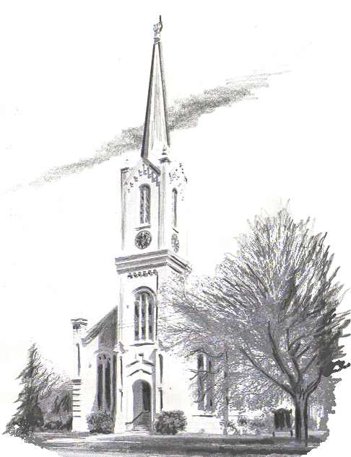

Website: www.fpcportgibson.com Study Telephone: 437-5428
Manse Address: 1101 Church Street Manse Telephone: 437-5887

